***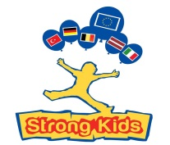*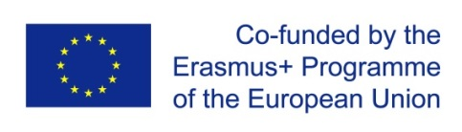**

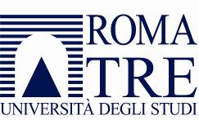**Strong Kids Erasmus Plus Project 2018**

Çanakkale Onsekiz Mart University - Turkey

21-25 March

**Dissemination Photos and Videos**

Sandra Chistolini

Università degli Studi Roma Tre - Italy

[www.sandrachistolini.it](http://www.sandrachistolini.it)

**Dissemination**

<http://www.uniroma3.it/articoli/pre-strong-kids-congress-canakkale-2018-10962/>

<https://www.siped.it/strong-kids-congress-canakkale-2018-22-25-marzo-kepez-belediyesi-canakkale-merkez-turchia/>

<http://www.sandrachistolini.it/?p=5274>

**700 Photos**

<https://www.dropbox.com/sh/fpfs66betmburqi/AAAWRDVw3L0kHnb5ZfsH4Dmca?dl=0>

**Videos**

Strong Kids Erasmus Plus Project 2018

Outdoor Education Workshop Cabacam

Canakkale 22 March 2018

Turkey

Part One

<https://youtu.be/0XVZT158XQE>

Strong Kids Erasmus Plus Project 2018

Outdoor Education Workshop Cabacam

Canakkale 22 March 2018

Turkey

Part Two

<https://youtu.be/TzCCNC5TxEA>

Strong Kids Erasmus Plus Project 2018

Outdoor Education Workshop Cabacam

Canakkale 22 March 2018

Turkey

Part Three

<https://youtu.be/nsrvY100bfk>

Strong Kids Erasmus Plus Project 2018

Outdoor Education Workshop Cabacam

Canakkale 22 March 2018

Turkey

Part Four

<https://youtu.be/Bgc8yhDYrtU>

**Congress**

Strong Kids Canakkale Congress 2018 Preprimary and Primary School Part I

<https://youtu.be/ayZ3-Cl-mLA>

Strong Kids Canakkale Congress 2018 Preprimary and Primary School Part II

<https://youtu.be/TIsGcc0un1U>

Strong Kids Canakkale Congress 2018 Preprimary and Primary School Part III <https://youtu.be/BnW_OVTiPQI>

Strong Kids Canakkale Congress 2018 Preprimary and Primary School Part IV

<https://youtu.be/siW5Ndl7AtM>

Strong Kids Canakkale Congress 2018 Preprimary and Primary School Part V

<https://youtu.be/PPPAf-5VCNk>

**Çabaçam**

Strong Kids Cabacam English lesson Children of 4-5 years

<https://youtu.be/93HrlZ6Ax2A>

Strong Kids Cabacam Identity Children of 4-5 years

<https://youtu.be/tPMWvUIU8WM>

Strong Kids Cabacam Music lesson Children of 4-5 years

<https://youtu.be/AXqnV6tYG-0>

Strong Kinds Cabacam Master of Darbulca 23 March 2018

<https://youtu.be/M0yBoLFAITQ>

Fark Yaratanlar - ÇABA-ÇAM

<https://youtu.be/OdpBfLKhPco>

**Workshop**

Strong Kids Workshop Belgium Circle Time

<https://youtu.be/ZSiHCsTmmNY>

Strong Kids Workshop Belgium Cooperation

<https://youtu.be/EhM-lPO0nIQ>

Strong Kids Workshop Germany Sport and Kids

<https://youtu.be/yGTYeAkfdkc>

Strong Kids Workshop Italy Outdoor Education Part I

<https://youtu.be/uZgM_otn8xw>

Strong Kids Workshop Italy Outdoor Education Part II

<https://youtu.be/1uAyGilUXYM>

Strong Kids Workshop Latvia Labyrinth Part I

<https://youtu.be/LmCu_juZfiQ>

Strong Kids Workshop Latvia Labyrinth Part II

<https://youtu.be/UsslOiyicb4>