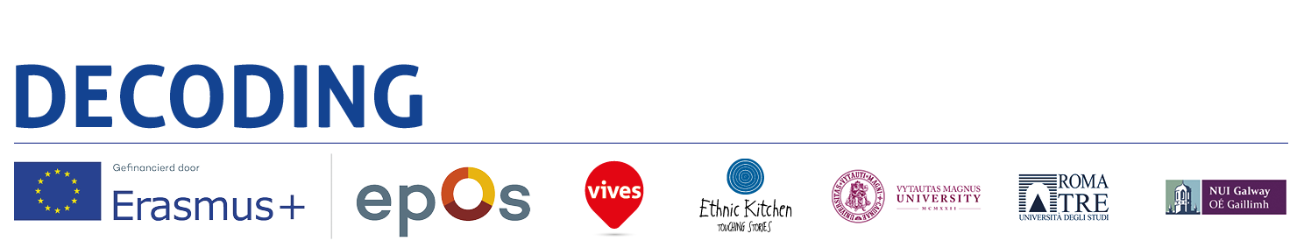**20th**

**CiCea International Conference 2018**and 2nd Joint Conference with CitizED

**Citizenship & Identity in a 'Post-Truth' World**

Hotel Ibis, Old Town, Warsaw, Poland

Thursday 10 - Saturday 12 May 2018

***Decoding the Disciplines* in higher education institutions and democratization**

**of knowledge to contrast the gap between cultures**

Sandra Chistolini, Università degli Studi Roma Tre, Italy

Hugo Verkest, Vives University College campus Torhout, Belgium

[schistolini@uniroma3.it](mailto:schistolini@uniroma3.it)

[hugo.verkest@vives.be](mailto:hugo.verkest@vives.be)

**Abstract**

Decoding the disciplines is an European project under the framework of Erasmus + KA2. It represents the current stage of development of the democratic vision of teaching at the university level with introduction of a dynamic sequence methodology, based on the understanding of the discipline taught and learned in classroom. All disciplines are involved: humanities, science and social studies. The priority purpose is to understand what to teach about an academic discipline and to monitor students' learning, to bring out the bottlenecks, which hinder the achievement of knowledge and slow down the learning process leading to failure. Knowing how to teach at university requires new and rarely monitored competences. Not all university teachers have the opportunity to follow an adequate teaching education, nor can they directly verify their ability to know how to teach and communicate the knowledge and the epistemological character of their discipline. European reports on the excellence of higher education highlight deficiencies to be defined and overcome, as well as possibilities for improvement also to adequately address the dispersion of students, often rejected in hidden and labyrinthine forms. The growing disciplinary gap between teacher and students assumes the shape of progressive removal from scientific truth. The theory of humanistic Weltshauung guides to think the qualification of teacher in terms of responsible participation in building the identity process. The methodology refers to the impact of higher education on training in critical thinking, mainly in Belgian and Italian landscapes, and notes the current important scientific acquisitions, with the eventual design of extension of the training of secondary school teachers. The project is coherent with the Council of the European Union of May 12, 2009 Conclusion, “ET 2020". Decoding interprets citizenship as culture open access. Presentation of initial results aims to receive a feedback on our still in progress study.

**Key words:** Decoding the Disciplines, Democracy, Identity, Citizenship, Truth, Education